**2019-20 K-12 Kev Rov Ua Pov Thawj Qib Raws Tus Lej**

**Daim Ntawv Qhia: 0%, 20%, 40%, 60%, 80%, 100%**

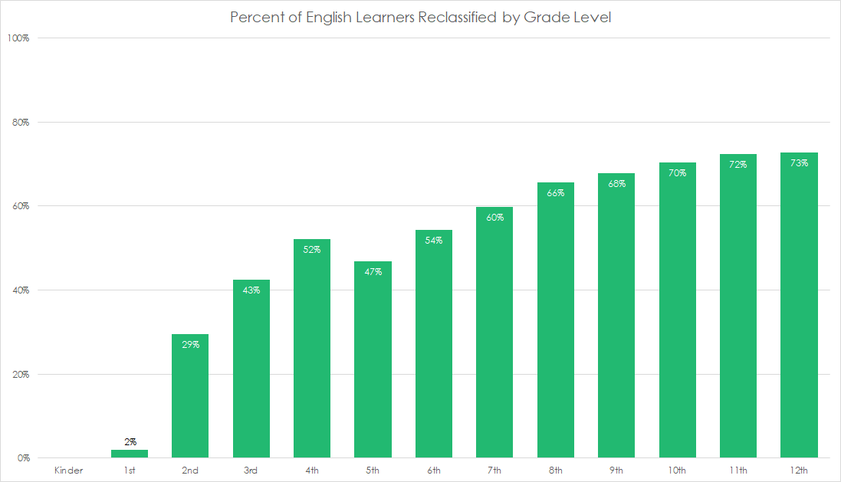

*Qhov chaw los: California Lub Chaw Ua Hauj Lwm Saib Xyuas Kev Kawm. (Lub ob hlis xyoo 2021). 2019-20 "Ever-ELs" los ntawm xyoo ua EL thiab Rov Ua Pov Thawj (RFEP) Cov xwm txheej thiab Qib (Tsab Ntawv Qhia Txog Kev Ntsuas Cov Ntaub Ntawv).*

Rov Ua Pov Thawj Qhov txheej txheem uas ib tug tub ntxhais kawm ntawv raug faib los ntawm Neeg Kawm Lus Askiv kom paub Lus Askiv npliag.

**2019-20 Feem pua ntawm Cov Kawm Ntawv Askiv raug faib los ntawm Qib Kawm**

|  |  |
| --- | --- |
| **Me Nyuam Yaus** |  |
| **1st** | **2%** |
| **2nd** | **29%** |
| **3rd** | **43%** |
| **4th** | **52%** |
| **5th** | **47%** |
| **6th** | **54%** |
| **7th** | **60%** |
| **8th** | **66%** |
| **9th** | **68%** |
| **10th** | **70%** |
| **11th** | **72%** |
| **12th** | **73%** |

**Coj Txoj Kev**

Yog tias Cov Neeg Kawm ntawv Askiv tsis tau txheeb xyuas txog thaum lawv tawm hauv tsev kawm ntawv theem qis, tsuas muaj 50 feem puas feem ntau uas lawv yuav raug faib ua ntu zus thaum nyob hauv Fresno cov tsev kawm ntawv.

Thaum tsoom fwv hauv nroog Fresno cov tsev kawm ntawv txheeb xyuas cov tub ntxhais kawm nyob rau qib 2, 3, thiab 4 ntawm tus lej nrawm dua li lub xeev California, cov ntaub ntawv tau qhia tias ntau tshaj li ib feem peb ntawm Cov Kawm Lus Askiv tsis tau faib ua ntej yuav tawm hauv nroog Fresno cov tsev kawm qib siab.

**Muaj cov pawg neeg twg uas kuv tuaj yeem koom nrog los sis cov rooj sib tham twg tuaj yeem koom nrog txhawm rau txhawb nqa Cov Kawm ntawv Askiv?**

[**Txiav txim Siab Koom nrog Pawg Neeg Pab Tswv Yim Kawm Ntawv Askiv (ELAC).**](https://els.fresnounified.org/elac/#who-can-serve-on-the-elac)Hauv Paus Tsev Kawm Ntawv Fresno txhais ELAC yog "pawg niam txiv thiab cov neeg zej zog uas qhia thiab pab tsev kawm ntawv los txiav txim siab tseem ceeb ntsig txog kev pabcuam rau Cov Kawm ntawv Askiv.” **Raws txoj cai lij choj, pawg ELAC yuav tsum tau tsim nyob rau txhua lub tsev kawm ntawv uas muaj ntau tshaj 20 Cov Neeg Kawm ntawv Askiv.**

ELAC cov rooj sib tham yog txoj kev zoo rau kev nkag siab zoo kom pab txhawb nqa Cov Kawm Ntawv Askiv tau txais ntawm qhov chaw. ELAC cov tswv cuab tseem muaj sij hawm los tawm lus qhuab qhia txog tsev kawm ntawv txoj kev pab cuam kev kawm rau Cov Kawm Ntawv Askiv.

[**Koom Nrog LCAP Lub Rooj Sib Tham**](https://stafed.fresnounified.org/lcap/)**.** Txhua xyoo, hauv paus tsev kawm tau txais nyiaj tshwj xeeb los pab nws kom tau zoo rau Cov Kawm Ntawv Askiv, cov tub ntxhais kawm tau nyiaj tsawg, thiab cov hluas nyob nrog niam qhuav txiv qhuav. Hauv Paus Tswj Kev Tswj thiab Feem Peev Xwm (LCAP) yog qhov uas hauv paus tsev kawm ntawv piav qhia lawv yuav siv cov nyiaj ntawv mus li FUSD nrhiav zej zog cov lus qhia txhua xyoo nyob rau nws qhov LCAP thiab tsim kho los ntawm cov lus tau txais ua ntej xyoo kawm ntawv yuav pib. Cov ncauj lus tawm tswv yim no yog ib txoj hau kev rau cov tsev neeg ntawm Cov Kawm Lus Askiv kom kawm paub ntau ntxiv txog qhov ua tau zoo thiab qhov khoob ntawm cov kev kawm niaj hnub no muaj rau lawv cov menyuam thiab tawm tswv yim rau yam uas lawv xav ua txawv nyob rau xyoo tom ntej.